|  |  |  |  |  |  |
| --- | --- | --- | --- | --- | --- |
| **RJIL IDC**  **Standard Operating Procedure**  **NMON check and NMON installation via HPSA** | | | | | |
| 00 | 23-Aug-16 | Issued For Use |  |  |  |
| Deepa Nayak |  |  |
| **Rev. No.** | **Date** | **Reason for Issue** | **Prepared by** | **Reviewed by** | **Approved by** |

Printouts of this document shall be deemed uncontrolled.

Amendment Record / Control Sheet (ACS)

| Rev. No. | Date | Reason  for Issue | Prepared by | Reviewed by | Approved by | Details of Amendments / Revisions |
| --- | --- | --- | --- | --- | --- | --- |
| 00 | 23-Aug-16 |  |  |  |  |  |
|  |  |  |  |  |  |  |

Document Version History

| Rev. No. | Date | Revised by | Approved by | Details of Amendments / Revisions |
| --- | --- | --- | --- | --- |
| 1.0 | 23-Aug-16 |  |  | New document. |
|  |  |  |  |  |
|  |  |  |  |  |
|  |  |  |  |  |
|  |  |  |  |  |
|  |  |  |  |  |
|  |  |  |  |  |
|  |  |  |  |  |
|  |  |  |  |  |
|  |  |  |  |  |
|  |  |  |  |  |
|  |  |  |  |  |
|  |  |  |  |  |

Table of Contents

1. NMON check and NMON installation via HPSA

* Login to HPSA with username and password

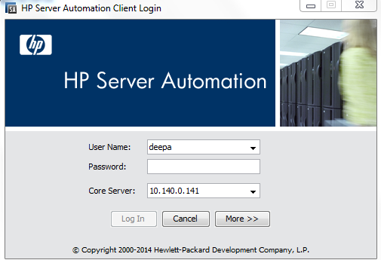

* Type of NMON script into HPSA.
  + NMON check.
  + NMON installation.
* Step to copy the script
* Script name: NMON_CHECK
* Click on library -> by folder-> script->right click->server script…

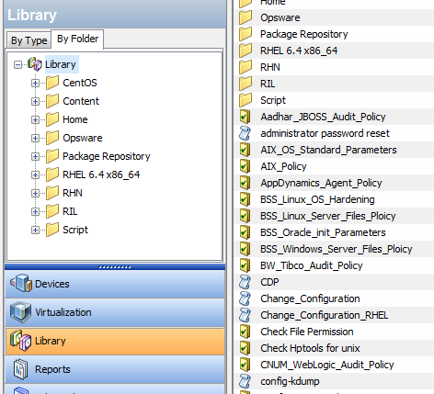

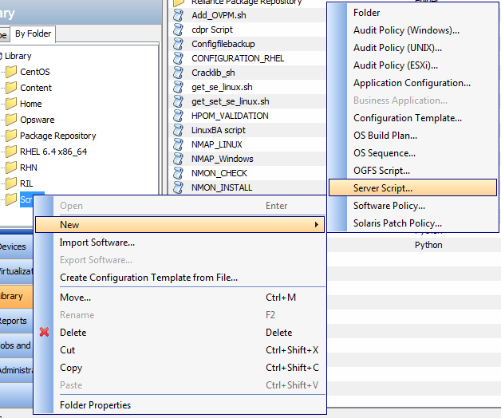

* Click on server script and fill the following details:

Name : <script name as per user convenience>

Type : < script run type EX: UNIX, WINDOW etc.>

Script content: < copy the script >

Description :< give the script description>

Click on file and save the changes.

* Step to run the NMON check script:

Select the sever from device->all managed list

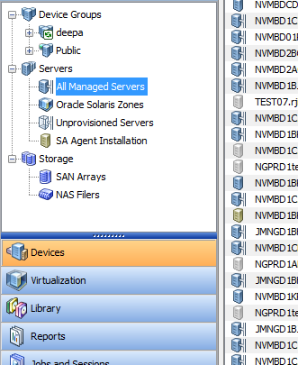

* Select the servers were you want to run the NMON check script to check whether NMON agent is installed or not

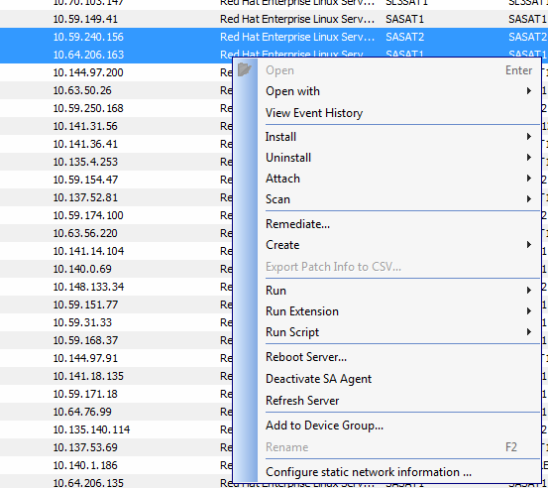

1. Step to run the NMON script in selected servers

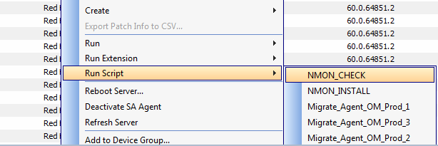

* Click on start job after select correct script from the above list

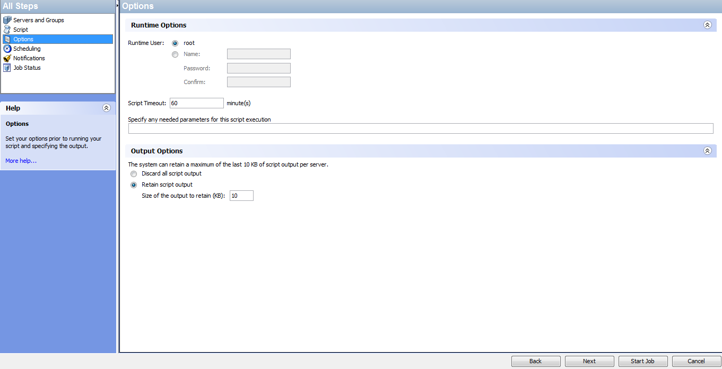

* Wait till task to complete and select the server which you want to refer the output

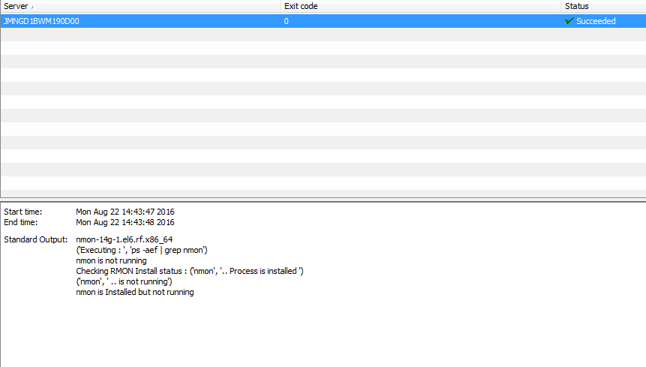

1. Step to run NMON installation script

Select the sever from device->all managed list



* Select the servers were you want to run the NMON install script to install NMON.



1. Step to run the NMON script in selected servers

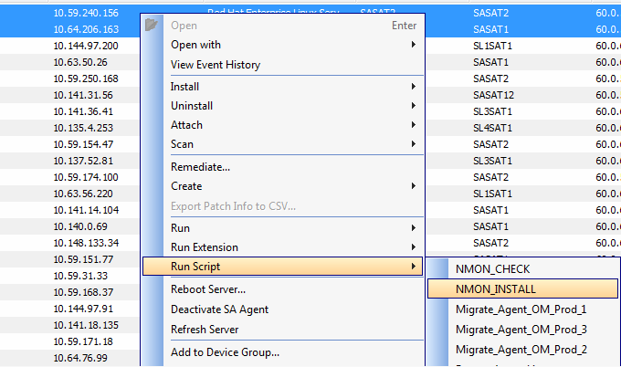

* Click on start job after select correct script from the above list



* Wait till task to complete and select the server which you want to refer the output

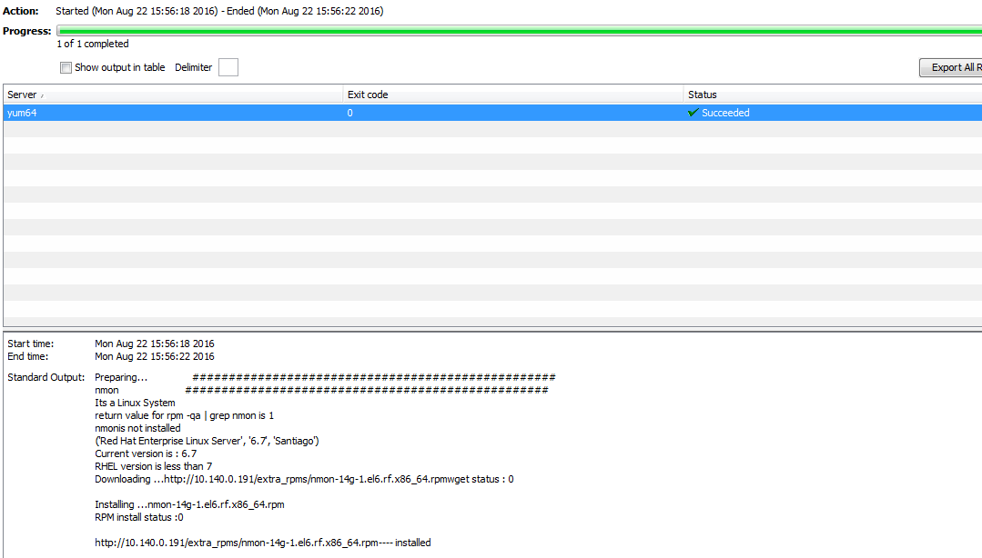

1. Below is the output will receive after completion of job:

Preparing... ##################################################

nmon ##################################################

Its a Linux System

return value for rpm -qa | grep nmon is 1

nmonis not installed

('Red Hat Enterprise Linux Server', '6.7', 'Santiago')

Current version is : 6.7

RHEL version is less than 7

Downloading ...http://10.140.0.191/extra_rpms/nmon-14g-1.el6.rf.x86_64.rpmwget status : 0

Installing ...nmon-14g-1.el6.rf.x86_64.rpm

RPM install status :0

http://10.140.0.191/extra_rpms/nmon-14g-1.el6.rf.x86_64.rpm---- installed